Application Form
For Recognition of
Post-Graduate Teacher
2024-2025
(For SPU Approved Teachers Only)

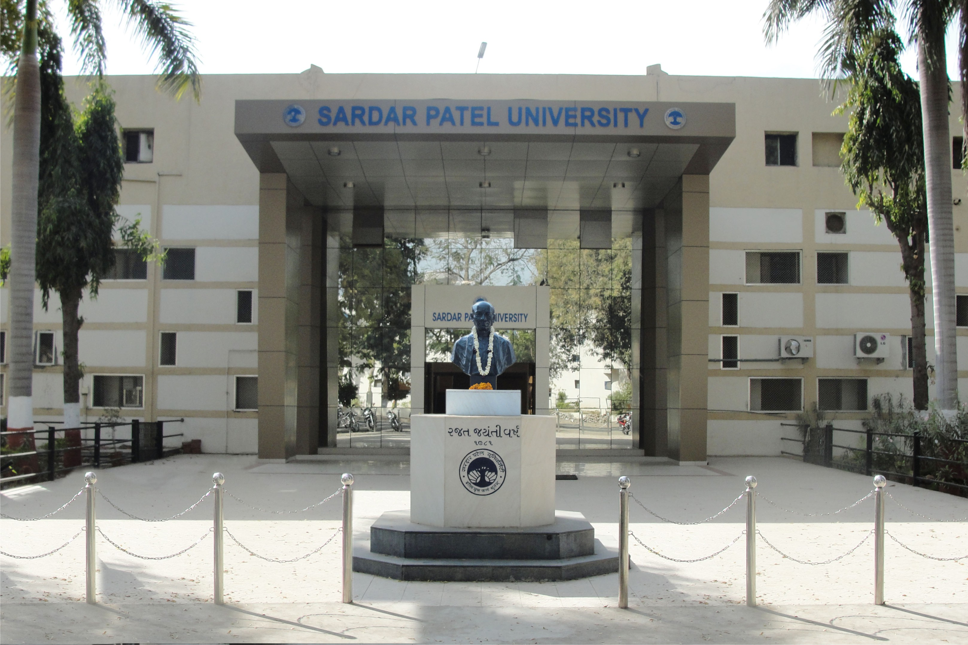

Sardar Patel University
Vallabh Vidyanagar – 388 120
Dist. Anand. Gujarat (India)
Website : www.spuvvn.edu

NAAC Re-Accreditation CGPA 3.11 Grade – “A”

Sardar Patel University
Rules and Regulations for Post-Graduate teachers in the University
[Revised in Compliance of the UGC (Minimum Standards and Procedures for the Award of M. Phil. /Ph. D. Degree) Regulation, 2016 as notified in The Gazette of India
(No.278, Part III – Section 4) 5 July 2016.]
R. PGR.1 For Master’s Degree:
(a) Full time teachers (with qualifications prescribed by the UGC from time to time appointed in under-graduate colleges or persons employed in recognized institutions with Ph.D. degree/NET/GSLET are automatically recognized as P.G. teachers for Master degree in relevant subject.
(b) Full time teachers as above without Ph.D. to be recognized for a post-graduate teaching work should have the three years experience of under graduate teaching or two years P.G. experience elsewhere. The teacher having M.Phil. degree may be given relaxation in experience of one year.
R. PGR.2

Moreover, the existing rules for recognition as post-graduate teacher for Master degree the made applicable for recognition as Post-Graduate teacher for Master’s degree in Industrial Chemistry as well as other such disciplines and the teaching experience of Post B.S. Diploma be also considered in place of Bachelor’s degree examination wherever necessary.

Sardar Patel University

Vallabh Vidyanagar – 388120

General Instructions TO FILL UP APPLICATION FORM FOR Recognition of POST-GRADUATE TEACHER: 2024-2025
(Note : The application of Adhyapak Sahayak and Temparary teachers shallnot be considered (Post Graduate Board of Studies and Research Item no. 47(7) dated : 03/05/2017)

- The candidates must read the conditions of eligibility as given in P. G. Teacher Regulation www. .spuvvn.edu/studentcorner/academic_programs/post graduate programme and must satisfy themselves regarding their eligibility for the recognition before filling the application form.

- Candidates who are desirous of applying for recognition in more than one subject will have to submit separate prescribed application form for each subject with separate application Fee.

- The Application Fee Rs. 25/- + Application Processing Fee Rs 500/- = Rs 525/- should be payable through Demand Draft in favor of the “Registrar, Sardar Patel University” drawn in any Nationalized Bank payable at Vallabh Vidyanagar. Write your Name, Address, and Mobile/Telephone Number on the back of the Demand Draft. The Application Form and Processing Fees shall not be refunded.

- Last date of Application: 05/07/2024

- Applications received after the last date will not be accepted/ entertained. University will not be responsible for any postal delays/loss. Late and defective applications will be summarily rejected and no further correspondence will be entertained in this regard.

- This application is valid only for academic year 2024-2025. There is no provision for reevaluation and reassessment of application once rejected (not recommended) by committee.

- Applicant is requested to enclose all the required attachment (documents) as per serial number mentioned in the application.

- Attachment of sr. no. 09 of application (i.e. University approved letter and appointment letter by Institute) is mandatory.

- Application will not be considered solely on the basis of satisfying the criteria for recognition because the committee concerned for recommending recognition may use its discretion in making its recommendation.

- Application form must be complete in all respects as per the format. All incomplete (lake of supporting documents, marksheet, appoint letter, Experience letter, Publication proof, University teacher approval) application forms will be rejected.

- It is essential for the applicant forward the application through proper channel and application not sent through proper channel are liable to be rejected.

- Applicant shall inform the University without fail if they were booked for adopting unfair means and were punished for the same. In case they have been booked for adopting unfair means and a decision is awaited then the decision of the University will be final.

- Applications submitted on any other format (including old format) will not be accepted.

- The applicants in their own interest are requested to retain a photocopy of the Application Form, Fee Receipt and Demand draft for record.

- The decision of the Honorable Vice-Chancellor shall be final on any dispute.

- The Application form duly completed in all respect should be sent before last date of receipt of application form on the following address:
Registrar,
Academic Section,
Sardar Patel University
Vallabh Vidyanagar – 388 120
Dist. Anand, Gujarat (India).

SARDAR PATEL UNIVERSITY

Vallabh Vidyanagar

No. ____________
Fee Rs. 525/-*
Code. No. 30778

FORM OF APPLICATION FOR RECOGNITION OF
POST-GRADUATE TEACHER: 2024-2025

--------------------------------------------------------------------------------------------------------------------------------------------------------------------------------------------------------------------------------------------------------------------------------------------------------------

Instructions: -

(1) Please read all the general instructions carefully before filling up the Application form.

(2) This application form is valid for one-time i. e. Academic year 2024-2025.

(3) Applications received after the last date will not be entertained / accepted. University will not be responsible for any postal delays/loss.
(4) Incomplete application shall not be considered.
(5) If any column is not applicable to the candidate concerned in that column please write “Not Applicable”.
(6) Sardar Patel University reserves the right to reject any application without giving any reason.
(7) It is essential for the applicant forward the application through proper channel and application not sent through proper channel are liable to be rejected.
(8) Please refer the latest rules for recognition of Teacher as a P. G. Teacher before filling the application form, on university web site: http://www.spuvvn.edu/studentcorner/academic_programs/post graduate programme
(9) *The Application Fee Rs. 25/-+ Application Processing Fee Rs 500/- = Rs 525/- payable through Demand Draft in favor of the “Registrar, Sardar Patel University” drawn in any Nationalized Bank payable at Vallabh Vidyanagar. Write your Name, Address, and Mobile/Telephone Number on the back of the Demand Draft. The Application Form and Processing Fees shall not be refunded.
-------------------------------------------------------------------------------------------------------------------------------------------------------------------------------------------------------------------------------------------------------------------------------------------------------------
Particulars of the subject for which P.G. Teacher recognition is sought.
Subject: ___________________________________________________

PARTICULARS OF TEACHER (APPLICANT)
1. Name in full: ___________________________________________________________________
2. Designation: ___________________________________________________________________
3. Name of the College/Department of the University: ____________________________________
4. Address (Office) ___________________________________________________________
___________________________________________________________
Address (Residential) ___________________________________________________________
___________________________________________________________
Mobile No.:______________________________ Land Line No._________________________
E-mail: ______________________________________________________________________
5. Qualification: (Please attach all the mark sheets & relevant certificates)

Name of Degree | Class/  Percentage | Month & Year of Passing | Name of the University/ College | Principal/Major  Subject | Encl. at Page No.
6. * (A) Teaching experience (Please attach relevant certificates or proof) at Post-graduate level as full time teacher (As per R.Ph.D. 1)
* (Note: By teaching, it is meant teaching of the subject for which recognition is sought)

Name of University Department/College | Designation | Period of teaching |  | Total Experience |  | Encl. at Page No.
Name of University Department/College | Designation | From | To |  |  | Encl. at Page No.
 |  |  |  | Years | Months

* (B) Teaching experience at Graduate level as full time teacher (Please furnish relevant proof): (As per R.Ph.D. 1.1.1)
* (Note: By teaching, it is meant teaching of the subject for which recognition is sought)

Name of College | Name of the subject/ Courses taught | Period of teaching in the final year degree class |  | Total Experience |  | Encl. at Page No.
Name of College | Name of the subject/ Courses taught | From | To |  |  | Encl. at Page No.
 |  |  |  | Years | Months
7. Academic activities and advanced study:
(Please give details on a separate sheet)
(i) Refresher/Advanced courses attended in the subject concerned

8. Additional information, if any

 |  | Encl. at Page No.
9. | Approval of all appointments as a teacher with Syndicate Resolution No. ________ & Date _______________ (Please attach copies of the same for every appointment)

Please take a note that without Syndicate Approval Letter the Application Form shall be reject.

Application Summary:
No. | Particular | Yes | No | Encl. at Page No.
1 | Syndicate Approval in case of Affiliated Colleges/Institutes
2 | Ph. D.
3 | M. Phil.
4 | UG (3 years Experience)  PG (2 years Experience)

I have read & under stand the rules and general instruction given in application form, and I hereby declare that the information provided in this application form are correct to the best of my knowledge and understanding. In case of any Information furnished by me is found to be incorrect and/or to be to in compliance to the rules of the University, the University has the right to take any action it deems fit, including the derecognition of time. I promise to abide by the rules and regulation of the University in force from time to time.
Place:
Date: Signature of Teacher (Applicant): ___________________________
I declare that the above statement made by the applicant is correct to the best of my knowledge and belief.
I certified that:
(i) The applicant is a full-time teacher in the department/institute/ college from __________________ To __________________
(ii) The applicant fulfills the minimum eligibility for the recognition sought as per the latest rules for the same (Please refer the copy on www.spuvvn.edu/studentcorner/academic_programs/post graduate programme)
(iii) The applicant does not fulfill the minimum eligibility for the recognition sought as per the latest rules.
(iv) The candidate has submitted all the attested documents in support of his educational qualifications, teaching experience and other activities.
(Please strike out whichever is not applicable)

SEAL

_______________________________
Date: Signature of the Head of the
Place: University Department/
Principal of the College/
Director of Institute

Office Use Only
Remarks and recommendation of the committee members (Compulsory for further consideration)
No. | Particular | Yes/No
(1) | The candidate fulfills the eligibility as per the latest rules and hence is recommended for recognition as P.G. Teacher.
(2) | The candidate is not recommended for recognition because of the  (i) Lack of necessary teaching experience as per latest rules  (ii) Any other (Please specify)

No. | Name of Committee Members |  | Signature of committee members
1 |  | (Convener)
2 |  | (Dean)
3 |  | (Expert)
4 |  | (Member)
5 |  | (Member)
6 |  | (Member)
Date:
Place:

