Application Form
For
Recognition of Ph. D. (Research)Guide

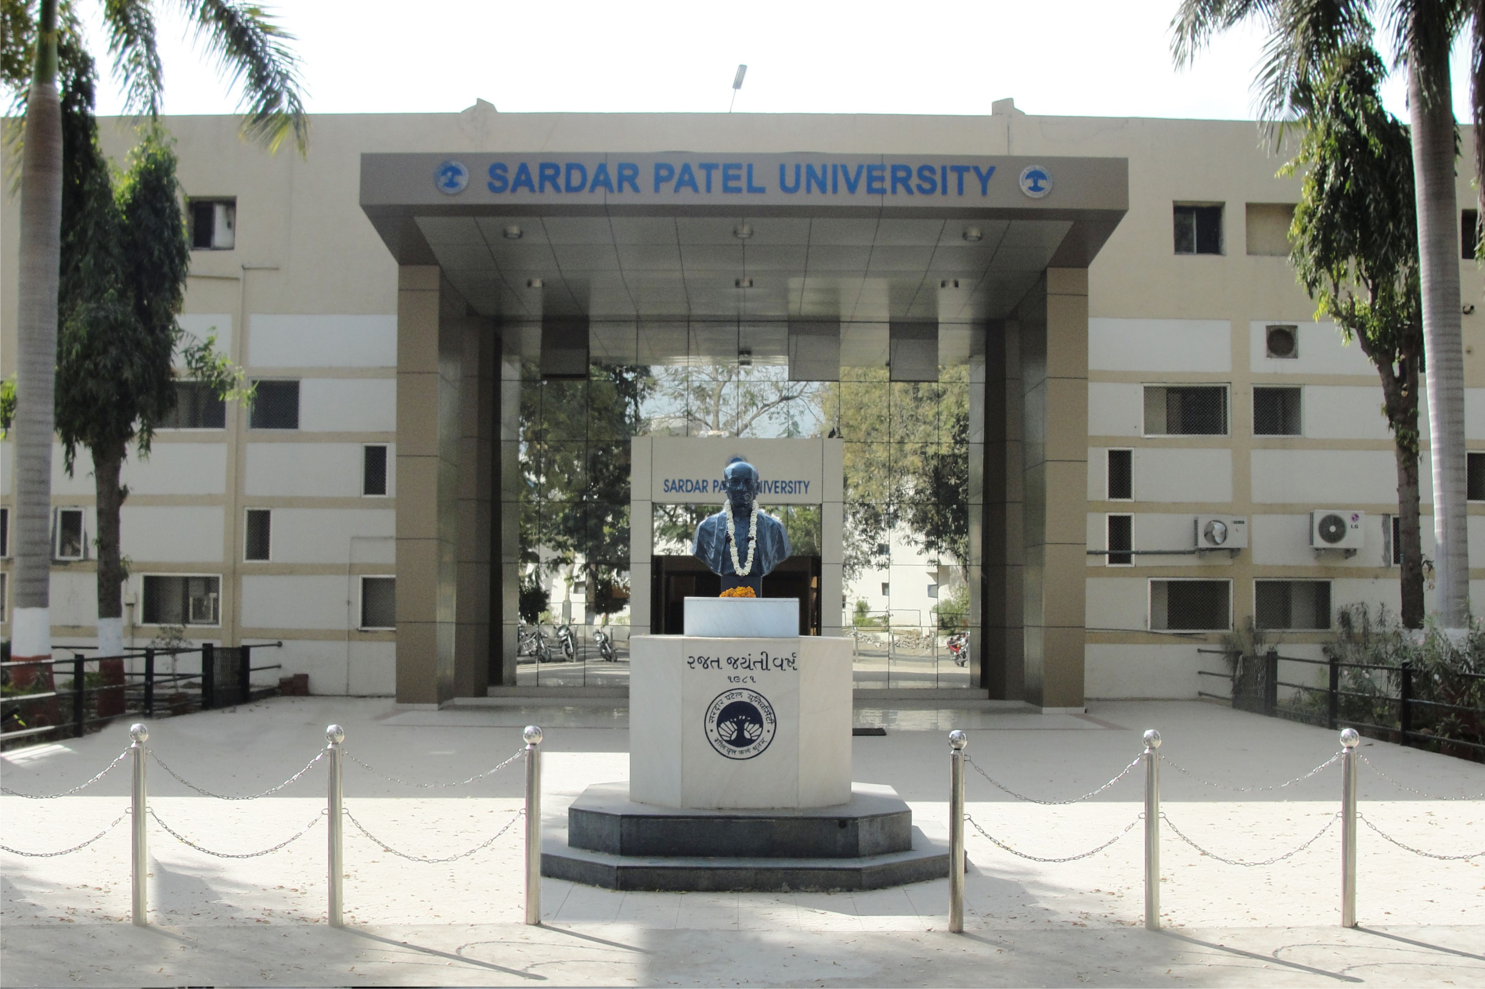


Sardar Patel University
Vallabh Vidyanagar – 388 120
Dist. Anand. Gujarat (India)
Website : www.spuvvn.edu

NAAC Re-Accreditation CGPA 3.25 Grade – “A”

Sardar Patel University

Vallabh Vidyanagar – 388120

General Instructions to fill up application form for RECOGNITION OF PH.D. GUIDE
(Note : The application of Adhyapak Sahayak and Temparary teachers shallnot be considered (Post Graduate Board of Studies and Research Item no. 47(7) dated : 03/05/2017)

- The candidates must read the conditions of eligibility as given in Ph. D. Regulation www.spuvvn.edu/academic_programs/phd and must satisfy themselves regarding their eligibility for the recognition before filling the application form.

- Candidates who are desirous of applying for recognition in more than one subject will have to submit separate prescribed application form for each subject with separate application Fee.

- The Application Fee Rs. 25/- + Application Processing Fee Rs 500/- = Rs 525/- should be payable through Demand Draft in favor of the “Registrar, Sardar Patel University” drawn in any Nationalized Bank payable at Vallabh Vidyanagar. Write your Name, Address, and Mobile/Telephone Number on the back of the Demand Draft. The Application Form Fee shall not be refunded.

- Last date of Application: 22/11/2019

- Applications received after the last date will not be accepted/entertained. University will not be responsible for any postal delays/loss. Late and defective applications will be summarily rejected and no further correspondence will be entertained in this regard.

- This application is valid only for academic year 2019-2020. There is no provision for reevaluation and reassessment of application once rejected (not recommended) by committee.

- Applicant is requested to enclose all the required attachment (documents) as per serial number mentioned in the application.

- Attachment of sr. no. 09 of application is mandatory and it should be as per prescribed performa.

- Application will not be considered solely on the basis of satisfying the criteria for recognition because the committee concerned for recommending recognition may use its discretion in making its recommendation.

- Application form must be complete in all respects as per the format. All incomplete ( lake of supporting documents, marksheet, Appoint letter, Experience letter, Publication proof, University teacher approval) application forms will be rejected.

- Applicant shall inform the University without fail if they were booked for adopting unfairmeans and were punished for the same. In case they have been booked for adopting unfairmeans and a decision is awaited then the decision of the University will be final.

- Applications submitted on any other format (including old format) will not be accepted.

- The applicants in their own interest are requested to retain a photocopy of the Application Form, Fee Receipt and Demand draft for record.

- The decision of the Honorable Vice-Chancellor shall be final on any dispute.

- The Application form duly completed in all respect should be sent before last date of receipt of application form on the following address:
Deputy Registrar,
Academic Section,
Sardar Patel University
Vallabh Vidyanagar – 388 120
Dist. Anand, Gujarat (India).
SARDAR PATEL UNIVERSITY

VALLABH VIDYANAGAR
No. ____________
Fee: Rs. 525*
Code No.: 10105

APPLICATION FORM FOR
RECOGNITION OF PH.D. GUIDE

--------------------------------------------------------------------------------------------------------------------------------------------------------------------------------------------------------------------------------------------------------------------------------------------------------------

Instructions:-

(1) Please read all the general instructions carefully before filling up the Application form.

(2) This application form is valid for one time i. e. Academic year 2019-2020.

(3) Applications received after the last date will not be entertained / accepted. University will not be responsible for any postal delays/loss.
(4) Imcomplete application shall not be considered.
(5) If any column is not applicable to the candidate concerned in that column please write “Not Applicable” or “NIL”
(6) Sardar Patel University reserves the right to reject any application without giving any reason.
(7) It is essential for the applicant forward the application through proper channel and application not sent through proper channel are liable to be rejected.
(8) Please refer the latest rules for recognition of Teacher as a Ph.D. Guide before filling the application form, on university web site: http://www.spuvvn.edu/academic_programs/phd
(9) *The Application Fee Rs. 25/-+ Application Processing Fee Rs 500/- = Rs 525/- payable through Demand Draft in favor of the “Registrar, Sardar Patel University” drawn in any Nationalized Bank payable at Vallabh Vidyanagar. Write your Name, Address, and Mobile/Telephone Number on the back of the Demand Draft. The Application Form Fee shall not refunded.
-------------------------------------------------------------------------------------------------------------------------------------------------------------------------------------------------------------------------------------------------------------------------------------------------------------
Particulars of the subject for which Ph.D. Guide recognition is sought;
Subject: _________________________ Branch of Subject:_____________________________

PARTICULARS OF TEACHER (APPLICANT)

1. Name in full ___________________________________________________________________
2. Designation ____________________________________________________________________
3. Name of the College/Department of the University _____________________________________
4. Address (Office) __________________________________________________________
Address (Residential) _________________________________________________________
__________________________________________________________
__________________________________________________________
Mobile No.:______________________________ Land Line No.__________________________
E-mail: _____________________________________________________________________
5. Qualifications: (Please attach all the mark sheets & relevant certificates.)
Name of Degree | Class/  Percentage | Month & Year of Passing | Name of the University/ College | Principal/  Major Subject | Encl. at Page No.

6. (A) *Teaching experience at Post-graduate level as full time teacher (Please furnish relevant proof):
* (Note: By teaching, it is meant teaching of the subject for which recognition is sought.)
Name of University Department/College | Designation | Period of teaching |  | Total Experience |  | Encl. at Page No.
Name of University Department/College | Designation | From | To |  |  | Encl. at Page No.
 |  |  |  | Years | Months

(B) *Teaching experience at Graduate level as full time teacher (Please furnish relevant proof):
* (Note: By teaching, it is meant teaching of the subject for which recognition is sought.)
Name of College | Name of the subject/ Courses taught | Period of teaching in the final year degree class |  | Total Experience |  | Encl. at Page No.
Name of College | Name of the subject/ Courses taught | From | To |  |  | Encl. at Page No.
 |  |  |  | Years | Months

7. Academic activities and advanced study: (Please give details on a separate sheet)

- Published work (Numbers Only):

(1) Books
Before Ph.D.: After Ph.D.:

(2) Research publications / articles in standard refereed journals
Before Ph.D.: After Ph.D.:
- Lectures delivered before academic societies, in colleges, in postgraduate departments and before similar bodies.
- Refresher/Advanced courses attended in the subject concerned.
- Details of participation in National/International Seminars/Conferences/Symposia/ Workshop.
(More participation in the above OR presentation of a paper in the above shall not be considered as publication)

8. Research Experience: (Please provide details for the period after the Ph.D. award)
Name of the Institution | Position | Type of work Done | From | To | Total Period |  | Encl. at Page No.
 |  |  |  |  | Years | Months | Encl. at Page No.

Title of the Ph.D. Thesis:

Date of Notification/Awarding of Ph. D. degree: _____________

Name of University: ___________________________________
*(Please attach Photocopy of title page)

9. Details of Research Publications with photo copies or reprints: (A separate declaration be provided by candidate)

 |  | Encl. at Page No.
1. | Please make an index on a separate sheet showing the title of the paper, name of the journal, month and year of publication and place of publication with ISBN,ISSN No.
2. | Attach photocopy of Full Paper and Index of Journal for Reference.
Note : Please note that conference abstracts/paper presentations are not considered as research publications.

 |  | Encl. at Page No.
10. | Approval of all appointments as a teacher with Syndicate Resolution No. ________ & Date _______________ (Please attach copies of the same for every appointment)

Please take a note that without Syndicate Approval Letter the Application Form shall be reject.

Application Summary :
No. | Particular | Yes | No
1 | Syndicate Approval
2 | Ph.D.
3 | M.Phil
4 | UG (4 years Experience) OR  PG (2 years Experience)
5 | For Professor at least Five Research Paper in last three years
6 | For Asst. & Asso. Professor at least Two Research Paper

I have read & under stand the rules and general instruction given in application form, and I hereby declare that the information provided in this application form are correct to the best of my knowledge and understanding. In case of any Information furnished by me is found to be incorrect and/or to be to in compliance to the rules of the University, the University has the right to take any action it deems fit, including the derecognition of time. I promise to abide by the rules and regulation of the University in force from time to time.
Place :
Date : Signature of Teacher (Applicant): ___________________________
I declare that the above statement made by the applicant are correct to the best of my knowledge and belief.
I certified that :
(i) The applicant is a full time teacher in the department/institute/ college from __________________ To __________________
(ii) The applicant fulfills the minimum eligibility for the recognition sought as per the latest rules for the same (Please refer the copy on www.spuvvn.edu/academic_programs/phd)
(iii) The applicant does not fulfill the minimum eligibility for the recognition sought as per the latest rules.
(iv) The candidate has submitted all the attested documents in support of his Educational qualifications, teaching experience and other activities.
(Please strike out whichever is not applicable)

SEAL

_______________________________
Date: Signature of the Head of the
Place: University Department/
Principal of the College/
Director of Institute

Office Use Only

Remarks and recommendation of the committee members (Compulsory for further consideration)

(1) The candidate fulfills the eligibility as per the latest rules and hence is recommended for recognition as Ph.D. guide.
(2) The candidate is not recommended for recognition because of the
(i) Lack of necessary teaching experience as per latest rules
(ii) Does not have required published papers as per latest rules.
(iii) Any other (Please specify)

No. | Name of Committee Members |  | Signature of committee members
1 |  | (Convener)
2 |  | (Dean)
3 |  | (Expert)
4 |  | (Member)
5 |  | (Member)
6 |  | (Member)

Date:
Place:

